**Code Inspection Rubric**

|  |  |  |  |
| --- | --- | --- | --- |
| **Category** | **Criteria** | **Score – Y/N** | **Comments** |
| **Code Formatting** | Is the code consistently  formatted (indentation, spacing)? | 5 |  |
| **Are line lengths reasonable and**  **within guidelines?** |  | 3 | Line 26 Menu.java  Line 23 Main.java  There a few lines with a long length (80+ characters) |
| **Are there unnecessary blank**  **lines or spaces?** |  | 5 | The blank lines and spaces help to understand the code better |
| **Naming Conventions** | Are variable and function names descriptive and  meaningful? | 5 | All the variables and functions explain themselves. |
| **Are naming conventions consistent (camelCase,**  **PascalCase, etc.)?** |  | 5 | Using camelCase convention |
| **Comments and Documentation** | Are comments used where  necessary and helpful? | 5 | The code is organized and understandable without comments. |
| **Is the code sufficiently documented to understand**  **functionality?** |  | 5 | There are no documented lines but it is understood |
| **Are comments clear and concise?** |  | 5 |  |
| **Code Structure** | Is the code modular and divided into logical  functions/methods? | 5 | Code modularization is efficient |
| **Are there any long methods/functions that should**  **be broken down?** |  | 4 | Most method names are 3 words long but the line 7 in CostCalculator.java |
| **Is there any duplicated code that**  **should be refactored?** |  | 5 | There is no duplicated code |
| **Logic and Functionality** | Does the code function as  intended? | 4 | There are algorithms that don’t fully perfom what is requested. |
| **Are all the requirements**  **fulfilled?** |  | 4 | Doesn’t allow you to change the selection when the order is canceled |
| **Are there any obvious logic**  **errors?** |  | 5 |  |
| **Are loop cases handled properly?** |  | 3 | The loop while of the method processOrder doesn’t handle uppercase. |
| **Error Handling** | Are errors and exceptions properly caught and  handled? | 5 |  |
| **Is there any potential for**  **unhandled exceptions?** |  | 5 | All the exceptions are handled |
| **Performance and Efficiency** | Are there any obvious  performance bottlenecks? | 5 |  |
| **Is the code optimized for**  **performance where necessary?** |  | 5 |  |
| **Security** | Are there any security  vulnerabilities in the code? | 4 | Maybe a denial of service can be applied when the product is ordered since there is no write extension restriction |
| **Is input validation properly**  **implemented?** |  | 5 |  |

Code review

1. Line length reasonable
2. 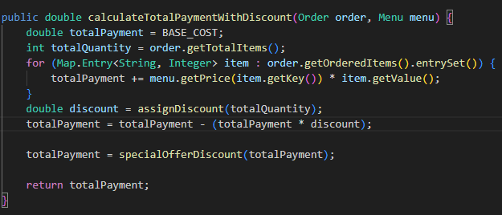Long method

Bugs and Issues Identified

1. There is a problem in the logic and functionality that doesn’t allow the products to be re-selected.

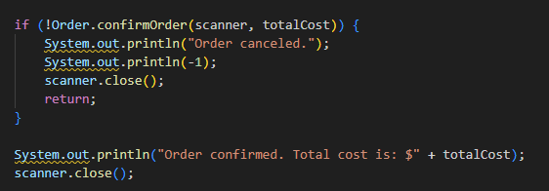

1. There is a vulnerability of denial of service because don’t restrict the input

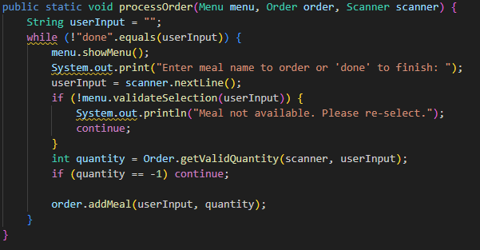

Code Quality Suggestions

1. Long lines methods can be broken down simpler words, and long lines of code can be placed on several lines.
2. The solution of the vulnerability can be a maximum long character input.